Dear CAHEC Partner,
CAHEC will be utilizing ShareFile, a secure file sharing platform, to collect copies of draft, final tax returns and audits and required backup documentation.
Below are the instructions to utilize ShareFile to submit your year-end documents.

- Access the ShareFile portal by visiting the CAHEC website at www.cahec.com and clicking on the Partner Portals link at the top of the page.

- Click on the CPAs/GPs/Management Agents Document Upload Portal. This will bring up the document upload portal page.
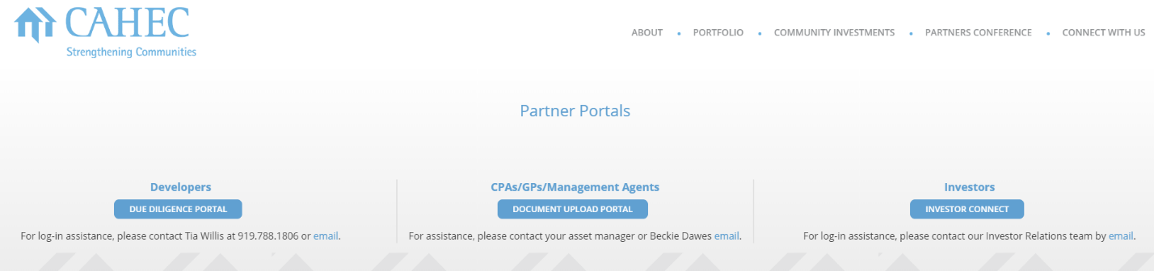

- The document upload portal page contains valuable deadline, submission and naming convention information and the links to upload draft and final tax returns, audits and other required back-up checklist items.

- To upload a document, click on the applicable folder to begin the upload process and open the file upload screen.
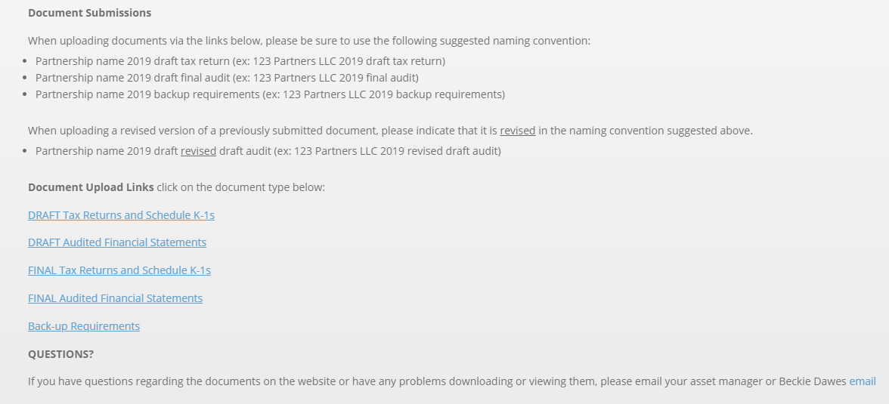

- To upload documents into a folder, enter your email address, first and last name and your company name. Then add the appropriate files for upload and click upload. Files can be added either by dragging and dropping into the upload box or by browsing and selecting the files you would like to upload.
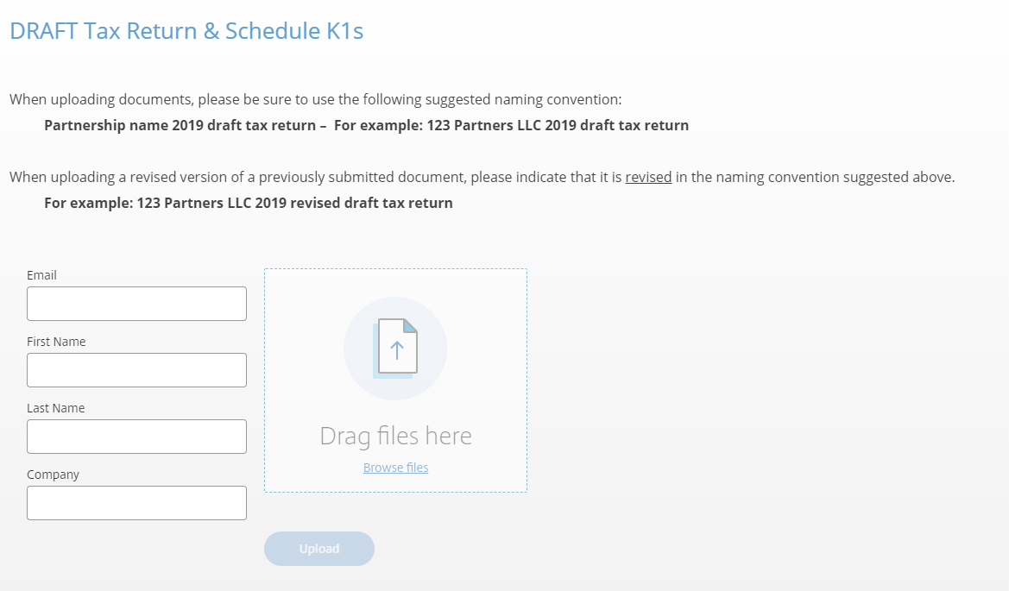

- Once a file has been successfully uploaded, the named file and “uploaded” will appear at the top of the upload box.
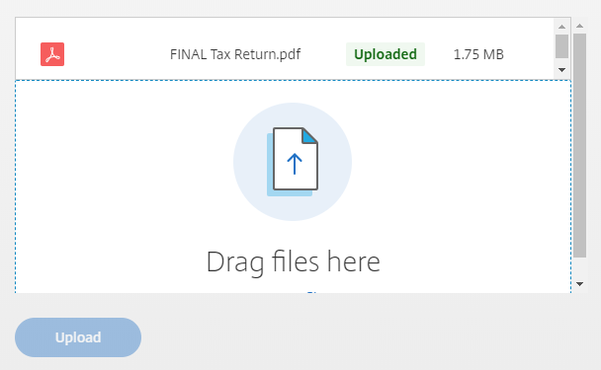

- Please do not send draft and final tax returns and audits and other back-up checklist documents to the AssetManagementReports@cahec.com email address. They will not be accepted, and you will receive a return email instructed you to use the ShareFile portal.

- If you have questions regarding the documents on the website or have any problems downloading or viewing them, please email your asset manager or Will Lane (wlane@cahec.com) or George Rapp (grapp@cahec.com).

